**Question 6.**

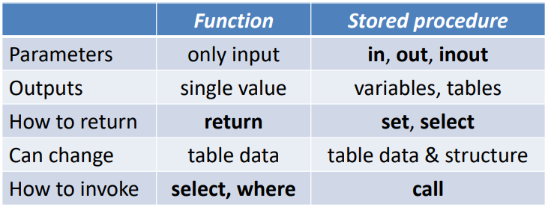**Example:**

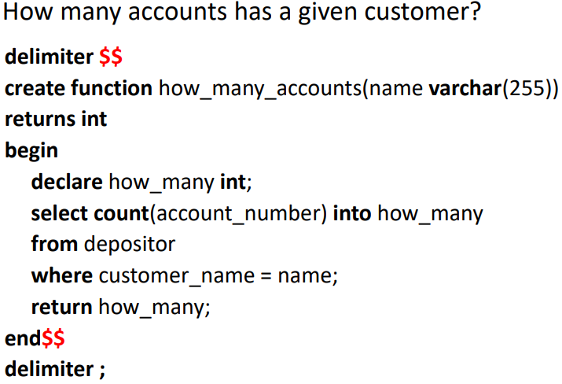Functions return something, procedures don’t.

Diference between SET and SELECT -> [link](https://stackoverflow.com/questions/3974683/how-to-set-variable-from-a-sql-query)

What is the difference between using @ and not using @?

Example:

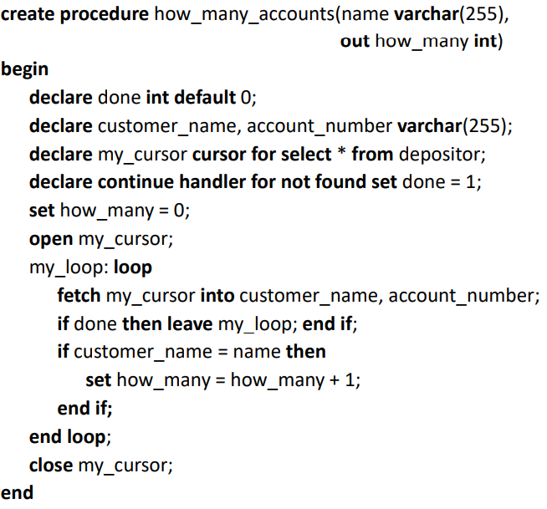

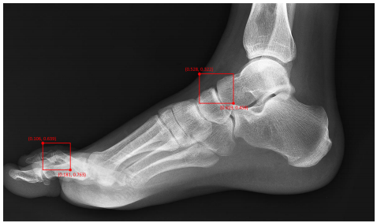

**Problema:**

Temos 2 rectângulos, queremos saber se existe alguma intersecção de áreas.

**Solução1:**

Verificar se algum dos 4 vertices de um rectângulo está contido na área do outro rectângulo.

As coordenadas dos 4 vértices são:

(x1, y1)

(x1, y2)

(x2, y1)

(x2, y2)

Se for verificado que existe um vértice da secção A contido na secção B então existe obrigatoriamente intersecção de conjuntos (return 1) caso contrário não existe intersecção (return 0).

**Alternative 1:**

**3**

delimiter $$

create function region_overlaps_element(idA varchar(255), indexA int, x1B int, y1B int, x2B int, y2B int) returns int

begin

SET @x1A = (SELECT x1 FROM Region WHERE elem_index = indexA and idA = series_id)

SET @y1A = (SELECT y1 FROM Region WHERE elem_index = indexA and idA = series_id)

SET @x2A = (SELECT x2 FROM Region WHERE elem_index = indexA and idA = series_id)

SET @y2A = (SELECT y2 FROM Region WHERE elem_index = indexA and idA = series_id)

if x1A > x1B and x1A < x2B and y1A > y1B and y1A < y2B

Return 1;

end if;

if x1A > x1B and x1A < x2B and y2A > y1B and y2A < y2B

Return 1;

end if;

if x2A > x1B and x2A < x2B and y1A > y1B and y1A < y2B

Return 1;

end if;

if x2A > x1B and x2A < x2B and y2A > y1B and y2A < y2B

Return 1;

end if;

return 0;

end$$

delimiter;

**Código Final:**

/*Returns 1 in case of overlap, sees if it doesn't overlap*/

delimiter $$

create function region_overlaps_element(idA varchar(255), indexA int, x1B int, y1B int, x2B int, y2B int)

returns int

begin

if (SELECT 1 FROM Region WHERE elem_index = indexA and idA = series_id and x1 > x2B) then

return 0;

end if;

if (SELECT 1 FROM Region WHERE elem_index = indexA and idA = series_id and x2 < x1B) then

return 0;

end if;

if (SELECT 1 FROM Region WHERE elem_index = indexA and idA = series_id and y1 > y2B) then

return 0;

end if;

if (SELECT 1 FROM Region WHERE elem_index = indexA and idA = series_id and y2 < y1B) then

return 0;

end if;

return 1;

end$$

delimiter ;

test inserts:

/*Overlaps*/

SELECT region_overlaps_element('O8', 1, 96, 120, 140, 200);

/*Overlaps*/

SELECT region_overlaps_element('O8', 1, 2, 5, 140, 200);

/*Doesn't overlap*/

SELECT region_overlaps_element('A4', 1, 20, 30, 21, 31);